SECTION 1: Identification

1.1. Identification
Product form | : | Mixture
Trade name | : | Polyurethane 350 VOC : Satin – Semi-Gloss
Product code | : | MP6682000 – MP6681000

1.2. Recommended use and restrictions on use
Recommended use | : | Wood floors
Restrictions on use | : | All other uses not recommended above

1.3. Supplier
Mercury Paint Corporation
4808 Farragut Rd
Brooklyn , New York 11203
T 718-469-8787
info@mercurypaint.com

1.4. Emergency telephone number
Emergency number | : | 1-800-858-8787  For Hazardous Materials or Dangerous Goods Incident Spill, Leak, Fire, Exposure, or Accident Call CHEMTREC Day or Night: 1-800-424-9300 (Toll Free, USA) / 703-527-3887 (Virgina, USA) CCN 14251

SECTION 2: Hazard(s) identification

2.1. Classification of the substance or mixture

GHS US classification
Flammable liquids Category 3 | Flammable liquid and vapor
Skin sensitization, Category 1 | May cause an allergic skin reaction
Germ cell mutagenicity Category 1B | May cause genetic defects
Carcinogenicity Category 1A | May cause cancer
Reproductive toxicity Category 2 | Suspected of damaging fertility or the unborn child
Aspiration hazard Category 1 | May be fatal if swallowed and enters airways
Full text of H statements : see section 16

2.2. GHS Label elements, including precautionary statements

GHS US labeling
Hazard pictograms (GHS US) | : | 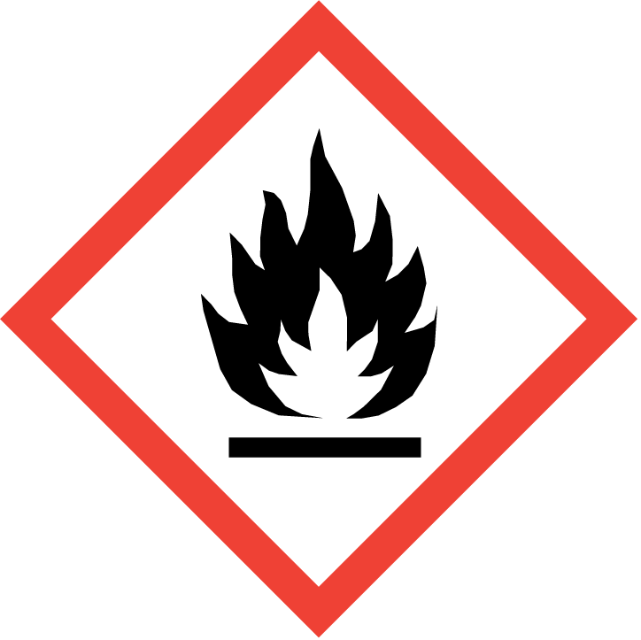 | 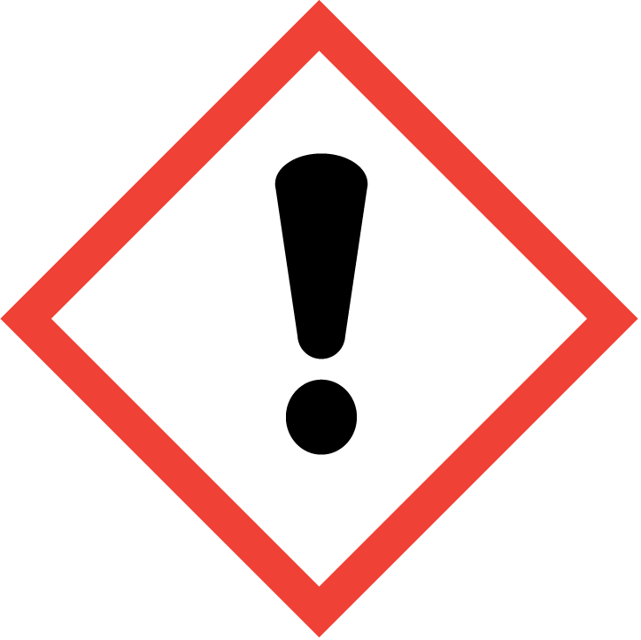 | 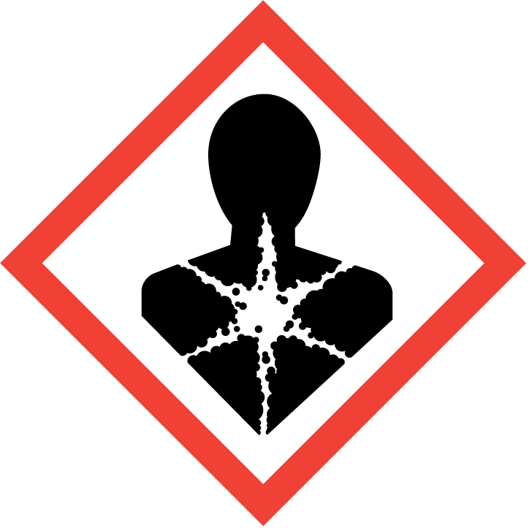
Signal word (GHS US) | : | Danger
Hazard statements (GHS US) | : | Flammable liquid and vapor  May be fatal if swallowed and enters airways  May cause an allergic skin reaction  May cause genetic defects  May cause cancer  Suspected of damaging fertility or the unborn child
Precautionary statements (GHS US) | : | Obtain special instructions before use.  Do not handle until all safety precautions have been read and understood.  Keep away from heat, hot surfaces, sparks, open flames and other ignition sources. No smoking.  Keep container tightly closed.  Ground/Bond container and receiving equipment.  Use explosion-proof electrical/ventilating/lighting equipment.  Avoid breathing spray, mist, vapors, gas.  Contaminated work clothing must not be allowed out of the workplace.  Wear protective gloves/protective clothing/eye protection/face protection.  If swallowed: Immediately call a poison center or doctor.  Do NOT induce vomiting.  If on skin (or hair): Take off immediately all contaminated clothing. Rinse skin with water/shower.  If skin irritation or rash occurs: Get medical advice/attention.  Wash contaminated clothing before reuse.  If exposed or concerned: Get medical advice/attention.  In case of fire: Use media other than water to extinguish.  Store in a well-ventilated place. Keep cool.  Store locked up.  Dispose of contents/container to hazardous or special waste collection point, in accordance with local, regional, national and/or international regulation.

2.3. Other hazards which do not result in classification
No additional information available

2.4. Unknown acute toxicity (GHS US)
40.41% of the mixture consists of ingredient(s) of unknown acute toxicity (Oral)
40.41% of the mixture consists of ingredient(s) of unknown acute toxicity (Dermal)
48.97% of the mixture consists of ingredient(s) of unknown acute toxicity (Inhalation (Dust/Mist))

SECTION 3: Composition/Information on ingredients

3.1. Substances
Not applicable

3.2. Mixtures
Name | Product identifier | % | GHS US classification
Octamethyl Cyclotetrasiloxane | CAS-No.: 556-67-2 | 10.00 – 10.90 | Repr. 2, H361  Aquatic Chronic 1, H410
Stoddard Solvent | CAS-No.: 8052-41-3 | 17.8 – 18.2 | Flam. Liq. 3, H226  Muta. 1B, H340  Carc. 1B, H350  Asp. Tox. 1, H304
Paraffinic Napthenic Solvent | CAS-No.: 64742-47-8 | 7.8 -8.0 | Flam. Liq. 3, H226  Asp. Tox. 1, H304
Naphtha, petroleum, light steam-cracked, debenzenized, polymers | CAS-No.: 68131-99-7 | 1.25-3 | Comb. Dust
Dimethyl Carbonate | CAS-No.: 616-38-6 | 1-5 | Flam. Liq. 2, H225
Quartz | CAS-No.: 14808-60-7 | 0.5- 0.6 | Carc. 1A, H350
2-Butanone oxime | CAS-No.: 96-29-7 | 0.34 – 0.355 | Flam. Liq. 4, H227  Acute Tox. 3 (Oral), H301  Acute Tox. 4 (Dermal), H312  Skin Irrit. 2, H315  Eye Dam. 1, H318  Skin Sens. 1, H317  Carc. 1B, H350  STOT SE 1, H370  STOT SE 3, H336  STOT RE 2, H373  Aquatic Chronic 2, H411
Hydrocarbons, C9, aromatics | CAS-No.: 64742-95-6 | 0.057 – 0.114 | Flam. Liq. 2, H225  Muta. 1B, H340  Carc. 1B, H350  Asp. Tox. 1, H304
Zinc bis(2-ethylhexanoate) | CAS-No.: 136-53-8 | - 0.14 | Eye Irrit. 2A, H319  Repr. 2, H361
Full text of hazard classes and H-statements : see section 16

SECTION 4: First-aid measures

4.1. Description of first aid measures
First-aid measures general | : | IF exposed or concerned: Get medical advice/attention. First aider: Pay attention to self-protection. Never give anything by mouth to an unconscious person. Give artificial respiration if necessary. Induce artificial respiration with mask fitted with one-way valve or other suitable device but not mouth-to-mouth.
First-aid measures after inhalation | : | If breathing is difficult, remove victim to fresh air and keep at rest in a position comfortable for breathing. If the victim is unconscious : Lay in a stable manner on victim's side. Induce artificial respiration with mask fitted with one-way valve or other suitable device; not mouth-to-mouth. Call a physician immediately.
First-aid measures after skin contact | : | Remove affected clothing and wash all exposed skin area with mild soap and water, followed by warm water rinse. If skin irritation or rash occurs: Get medical advice/attention. Wash contaminated clothing before reuse.
First-aid measures after eye contact | : | IF IN EYES: Rinse cautiously with water for several minutes. Remove contact lenses, if present and easy to do. Continue rinsing. If eye irritation persists: Get medical advice/attention.
First-aid measures after ingestion | : | Rinse mouth and spit the fluids out. Do NOT induce vomiting. If vomiting occurs, the head should be kept low so that vomit does not enter the lungs. Call a physician immediately.

4.2. Most important symptoms and effects (acute and delayed)
Symptoms/effects after inhalation | : | Aspiration of the product into the lungs may cause very serious pneumonia. Inhalation may cause irritation (cough, short breathing, difficulty in breathing).
Symptoms/effects after skin contact | : | May cause an allergic skin reaction.
Symptoms/effects after eye contact | : | Direct contact with the eyes is likely to be irritating.
Symptoms/effects after ingestion | : | Ingestion may cause nausea and vomiting. During vomiting high danger of aspiration. Gastrointestinal disturbances.
Most Important Symptoms/Effects | : | Depression of the central nervous system, headaches, dizziness, drowsiness, loss of coordination. Irritation to eyes, skin and respiratory tract. May be fatal if swallowed and enters airways. May cause an allergic skin reaction.
Chronic symptoms | : | May cause cancer. May cause heritable genetic damage. Suspected of damaging fertility.

4.3. Immediate medical attention and special treatment, if necessary
Treat symptomatically.

SECTION 5: Fire-fighting measures

5.1. Suitable (and unsuitable) extinguishing media
Suitable extinguishing media | : | Carbon dioxide. Dry powder. Foam.
Unsuitable extinguishing media | : | Do not use a heavy water stream.

5.2. Specific hazards arising from the chemical
Fire hazard | : | Flammable liquid and vapor.
Explosion hazard | : | Vapors are heavier than air and may travel considerable distance to an ignition source and flash back to source of vapors.
Hazardous decomposition products in case of fire | : | Toxic fumes may be released. Carbon dioxide. Carbon monoxide. Hydrocarbons. Sulphur oxides. Metallic oxides.

5.3. Special protective equipment and precautions for fire-fighters
Firefighting instructions | : | In case of major fire and large quantities: Evacuate area. Fight fire remotely due to the risk of explosion. Fight fire with normal precautions from a reasonable distance. Do not enter fire area without proper protective equipment, including respiratory protection. Eliminate all ignition sources if safe to do so. Get the package away from the fire if this can be done without risk.
Protection during firefighting | : | Do not attempt to take action without suitable protective equipment. Self-contained breathing apparatus. Complete protective clothing.

SECTION 6: Accidental release measures

6.1. Personal precautions, protective equipment and emergency procedures
General measures | : | Avoid all personal contact including breathing in the mist, spray, vapors, gas. Do not take actions involving personal risks. Stop leak if safe to do so. Notify authorities if product enters sewers or public waters.

6.1.1. For non-emergency personnel
Protective equipment | : | Wear recommended personal protective equipment.
Emergency procedures | : | Evacuate the danger area. If outdoors, move to an area upwind of the danger area. Avoid breathing mist, spray, vapors, gas. If possible without taking personal risks, remove ignition sources, ventilate area. No open flames, no sparks, and no smoking. Prevent other non-emergency personnel from entering the danger area.

6.1.2. For emergency responders
Protective equipment | : | Wear the recommended personal protective equipment. Do not attempt to take action without suitable protective equipment. For further information refer to section 8: "Exposure controls/personal protection".
Emergency procedures | : | Evacuate unnecessary personnel. Ventilate spillage area. Stop leak if safe to do so. Prevent from entering sewers, basements and workpits, or any place where its accumulation can be dangerous. All equipment used when handling the product must be grounded.

6.2. Environmental precautions
Very toxic to aquatic life with long lasting effects. Do not let the product reach soil, drains, sewers, or surface and ground water. Notify authorities if product enters sewers or public waters.

6.3. Methods and material for containment and cleaning up
For containment | : | Contain with non-combustible inert absorbent.
Methods for cleaning up | : | Small spill: Take up in non-combustible inert absorbent and place into container for disposal. For large spills, confine the spill in a dike and charge it with wet sand or earth for subsequent safe disposal. Use non-sparking tools. Contaminated absorbent material may pose the same hazard as the spilt product. Decontaminate surfaces and equipment with water and detergent. Until a sufficient level of dilution is achieved, the decontamination water may pose the same hazards as the product. This material and its container must be disposed of in a safe way, and as per local legislation.

6.4. Reference to other sections
For further information refer to section 8: "Exposure controls/personal protection". For further information refer to section 13.

SECTION 7: Handling and storage

7.1. Precautions for safe handling
Precautions for safe handling | : | Obtain special instructions before use. Do not handle until all safety precautions have been read and understood. Ensure good ventilation of the work station. Wear personal protective equipment. Do not breathe mist, spray, vapors, gas. Do not get in eyes, on skin, or on clothing. Keep away from heat, hot surfaces, sparks, open flames and other ignition sources. No smoking. Handling this product may result in electrostatic accumulation. Use proper grounding procedures. Floors, walls and other surfaces in the hazard area must be cleaned regularly.
Hygiene measures | : | Do not eat, drink or smoke when using this product. Always wash hands after handling the product. Contaminated work clothing should not be allowed out of the workplace.

7.2. Conditions for safe storage, including any incompatibilities
Storage conditions | : | Store in a cool, dry and well-ventilated area away from incompatible substances. Keep only in original container. Keep away from heat, hot surfaces, sparks, open flames and other ignition sources. No smoking. Keep container closed when not in use. Stored containers should be periodically checked for general condition and leakage.

SECTION 8: Exposure controls/personal protection

8.1. Control parameters

Polyurethane 350 VOC Satin
No additional information available

Stoddard Solvent (8052-41-3)
USA - ACGIH - Occupational Exposure Limits
Local name | Stoddard solvent
ACGIH OEL TWA | 100 ppm
Remark (ACGIH) | TLV® Basis: Eye, skin, & kidney dam; nausea; CNS impair
Regulatory reference | ACGIH 2024
USA - OSHA - Occupational Exposure Limits
Local name | Stoddard solvent
OSHA PEL TWA | 2900 mg/m³
 | 500 ppm
Regulatory reference (US-OSHA) | OSHA Annotated Table Z-1

Naphtha, petroleum, light steam-cracked, debenzenized, polymers (68131-99-7)
No additional information available

Paraffinic Napthenic Solvent
(64742-47-8)
No additional information available

Octamethyl Cyclotetrasiloxane (556-67-2)
No additional information available

Zinc bis(2-ethylhexanoate) (136-53-8)
No additional information available

2-Butanone oxime (96-29-7)
No additional information available

Dimethyl Carbonate (616-38-6)
No additional information available

Hydrocarbons, C9, aromatics (64742-95-6)
No additional information available

Quartz (14808-60-7)
USA - ACGIH - Occupational Exposure Limits
Local name | Silica crystaline - quartz
ACGIH OEL TWA | 0.025 mg/m³ (R - Respirable particulate matter)
Remark (ACGIH) | TLV® Basis: Pulm fibrosis; lung cancer. Notations: A2 (Suspected Human Carcinogen)
Regulatory reference | ACGIH 2024
USA - OSHA - Occupational Exposure Limits
Local name | Quartz (Total Dust) (Silica: Crystalline)
Remark (OSHA) | Table Z-3. For OSHA PEL (TWA) use formula: (30 mg/m3 / (%SiO2+2)) for mg/m3. CAS No. source: eCFR Table Z-1.
Regulatory reference (US-OSHA) | OSHA Annotated Table Z-3 Mineral Dusts

8.2. Appropriate engineering controls
Appropriate engineering controls | : | Ensure good ventilation of the work station. Use general ventilation, local exhaust ventilation or process enclosure to keep the airborne concentrations below the permissible exposure limits.
Environmental exposure controls | : | Avoid release to the environment. Take measures to reduce or limit air emissions and releases to soil and the aquatic environment.

8.3. Individual protection measures/Personal protective equipment
Personal protective equipment:
Personal protective equipment should be chosen according to national standards and in discussion with the supplier of the protective equipment. Wear recommended personal protective equipment.

Hand protection:
Protective gloves against chemicals (EN 374)

Eye protection:
Chemical goggles or face shield

Skin and body protection:
Wear suitable protective clothing

Respiratory protection:
Use NIOSH approved respirator if ventilation is inadequate. SCBA for emergency responders. Must be used in accordance with an OSHA complaint respiratory protection program.

Personal protective equipment symbol(s):

SECTION 9: Physical and chemical properties

9.1. Information on basic physical and chemical properties
Physical state | : | Liquid.
Appearance | : | Liquid.
Color | : | Amber
Odor | : | Solvent-like
Odor threshold | : | No data available
pH | : | No data available
Melting point | : | Not applicable
Freezing point | : | No data available
Boiling point | : | No data available
Flash point | : | 104 °F
Relative evaporation rate (butyl acetate=1) | : | No data available
Flammability (solid, gas) | : | Not applicable.
Vapor pressure | : | No data available
Relative vapor density at 20°C | : | No data available
Relative density | : | 0.93
Solubility | : | No data available
Partition coefficient n-octanol/water (Log Pow) | : | No data available
Auto-ignition temperature | : | No data available
Decomposition temperature | : | No data available
Viscosity, kinematic | : | No data available
Viscosity, dynamic | : | No data available
Explosion limits | : | No data available
Explosive properties | : | No data available
Oxidizing properties | : | No data available

9.2. Other information
VOC (g/l) ; 350 maximum

SECTION 10: Stability and reactivity

10.1. Reactivity
Flammable liquid and vapor.

10.2. Chemical stability
Stable under normal conditions of use.

10.3. Possibility of hazardous reactions
Stable under normal conditions of use.

10.4. Conditions to avoid
Avoid contact with hot surfaces. No flames, no sparks. Eliminate all sources of ignition. Incompatible materials.

10.5. Incompatible materials
Strong acids. Strong bases. Strong reducing agents. Oxidizing agents.

10.6. Hazardous decomposition products
Thermal decomposition generates : Hydrocarbons. Carbon dioxide. Carbon monoxide. Sulphur oxides. Metallic oxides.

SECTION 11: Toxicological information

11.1. Information on toxicological effects
Acute toxicity (oral) | : | Not classified
Acute toxicity (dermal) | : | Not classified
Acute toxicity (inhalation) | : | Not classified

Polyurethane 350 VOC Satin
Unknown acute toxicity (GHS US) | 40.41% of the mixture consists of ingredient(s) of unknown acute toxicity (Oral)  40.41% of the mixture consists of ingredient(s) of unknown acute toxicity (Dermal)  48.97% of the mixture consists of ingredient(s) of unknown acute toxicity (Inhalation (Dust/Mist))

Stoddard Solvent
LD50 oral rat | > 5000 mg/kg body weight
LD50 dermal rabbit | > 3000 mg/kg body weight
LC50 Inhalation - Rat | > 5.5 mg/l air

Paraffinic Napthenic Solvent

LD50 oral rat | > 5000 mg/kg body weight
LD50 dermal rabbit | > 2000 mg/kg body weight
LC50 Inhalation - Rat | > 5.28 mg/l air

Octamethyl Cyclotetrasiloxane
LD50 oral rat | > 4800 mg/kg body weight
LC50 Inhalation - Rat | 36 mg/l air

Zinc bis(2-ethylhexanoate)
LD50 dermal rat | > 2000 mg/kg body weight
LC50 Inhalation - Rat | > 5.7 mg/l/4h

2-Butanone oxime
LD50 dermal rabbit | > 1000 mg/kg body weight
LC50 Inhalation - Rat | > 4.83 mg/l air

Dimethyl Carbonate
LD50 oral rat | > 5000 mg/kg body weight
LD50 dermal rabbit | > 2000 mg/kg body weight
LC50 Inhalation - Rat | > 5.36 mg/l air

Hydrocarbons, C9, aromatics
LD50 oral rat | > 5000 mg/kg body weight

Skin corrosion/irritation | : | Not classified

Serious eye damage/irritation | : | Not classified

Zinc bis(2-ethylhexanoate)
Serious eye damage/irritation, rabbit | Severely irritating to the eyes

Respiratory or skin sensitization | : | May cause an allergic skin reaction.

Octamethyl Cyclotetrasiloxane
Additional information | No sensitizing reaction was observed for guinea pigs

Germ cell mutagenicity | : | May cause genetic defects.

Carcinogenicity | : | May cause cancer.

Quartz
IARC group | 1 - Carcinogenic to humans
National Toxicity Program (NTP) Status | Known Human Carcinogens

Reproductive toxicity | : | Suspected of damaging fertility or the unborn child.

Paraffinic Napthenic Solvent

NOAEL (animal/male, F0/P) | ≥ 3000 mg/kg body weight

STOT-single exposure | : | Not classified

2-Butanone oxime
STOT-single exposure | Causes damage to organs. May cause drowsiness or dizziness.

STOT-repeated exposure | : | Not classified

Stoddard Solvent
NOAEL (oral,rat,90 days) | 1056 mg/kg body weight
NOAEL (dermal,rat/rabbit,90 days) | 2000 mg/kg body weight

Paraffinic Napthenic Solvent

NOAEL (oral,rat,90 days) | 750 mg/kg body weight
NOAEL (dermal,rat/rabbit,90 days) | ≥ 495 mg/kg body weight

Zinc bis(2-ethylhexanoate)
NOAEL (subchronic,oral,animal/male,90 days) | 180 mg/kg body weight
NOAEL (subchronic,oral,animal/female,90 days) | 205 mg/kg body weight

2-Butanone oxime
LOAEL (oral,rat,90 days) | 40 mg/kg body weight
NOAEC (inhalation,rat,vapor,90 days) | 0.09 mg/l air
NOAEL (subchronic,oral,animal/male,90 days) | 110 mg/kg body weight
STOT-repeated exposure | May cause damage to organs through prolonged or repeated exposure.

Aspiration hazard | : | May be fatal if swallowed and enters airways.
Viscosity, kinematic | : | No data available

Stoddard Solvent
Viscosity, kinematic | 0.9 – 1.6 mm²/s Temp.: 'other:' Parameter: 'kinematic viscosity (in mm²/s)'

Octamethyl Cyclotetrasiloxane
Viscosity, kinematic | 1.6 mm²/s Temp.: '20°C' Parameter: 'kinematic viscosity (in mm²/s)'

Hydrocarbons, C9, aromatics
Viscosity, kinematic | < 1 mm²/s

Symptoms/effects after inhalation | : | Aspiration of the product into the lungs may cause very serious pneumonia. Inhalation may cause irritation (cough, short breathing, difficulty in breathing).
Symptoms/effects after skin contact | : | May cause an allergic skin reaction.
Symptoms/effects after eye contact | : | Direct contact with the eyes is likely to be irritating.
Symptoms/effects after ingestion | : | Ingestion may cause nausea and vomiting. During vomiting high danger of aspiration. Gastrointestinal disturbances.
Most Important Symptoms/Effects | : | Depression of the central nervous system, headaches, dizziness, drowsiness, loss of coordination. Irritation to eyes, skin and respiratory tract. May be fatal if swallowed and enters airways. May cause an allergic skin reaction.
Chronic symptoms | : | May cause cancer. May cause heritable genetic damage. Suspected of damaging fertility.

SECTION 12: Ecological information

12.1. Toxicity
Ecology - general | : | Very toxic to aquatic life with long lasting effects.

Stoddard Solvent
LC50 - Fish [1] | 2.5 mg/l
EC50 96h - Algae [1] | 0.58 mg/l
NOEC (chronic) | 0.1 mg/l

Octamethyl Cyclotetrasiloxane
LC50 - Fish [1] | > 22 μg/l
EC50 - Crustacea [1] | > 15 μg/l

2-Butanone oxime
LC50 - Fish [1] | > 100 mg/l
EC50 - Crustacea [1] | ≈ 201 mg/l
EC50 72h - Algae [1] | ≈ 11.8 mg/l
EC50 72h - Algae [2] | ≈ 6.09 mg/l
NOEC (chronic) | ≥ 100 mg/l

Dimethyl Carbonate
LC50 - Fish [1] | ≥ 100 mg/l
EC50 - Crustacea [1] | > 74.16 mg/l
EC50 72h - Algae [1] | > 57.29 mg/l
NOEC (chronic) | 25 mg/l

12.2. Persistence and degradability
Octamethyl Cyclotetrasiloxane
Persistence and degradability | Not rapidly degradable. 3.7 % biodegradation 28 days.

12.3. Bioaccumulative potential
No additional information available

12.4. Mobility in soil
No additional information available

12.5. Other adverse effects
No additional information available

SECTION 13: Disposal considerations

13.1. Disposal methods
Regional waste regulation | : | Disposal must be done according to official regulations.
Waste treatment methods | : | Dispose of contents/container in accordance with licensed collector’s sorting instructions.
Sewage disposal recommendations | : | Disposal must be done according to official regulations.
Product/Packaging disposal recommendations | : | Dispose of this material and its container at hazardous or special waste collection point. Refer to all applicable national, international and local regulations or provisions.
Additional information | : | Flammable vapors may accumulate in the container. Do not re-use empty containers.
Ecological information | : | Avoid release to the environment.

SECTION 14: Transport information
In accordance with DOT / IMDG / IATA
DOT | IMDG | IATA
14.1. UN number
1263 | 1263 | 1263
14.2. Proper Shipping Name
Paint | PAINT | Paint
14.3. Transport hazard class(es)
3 | 3 | 3
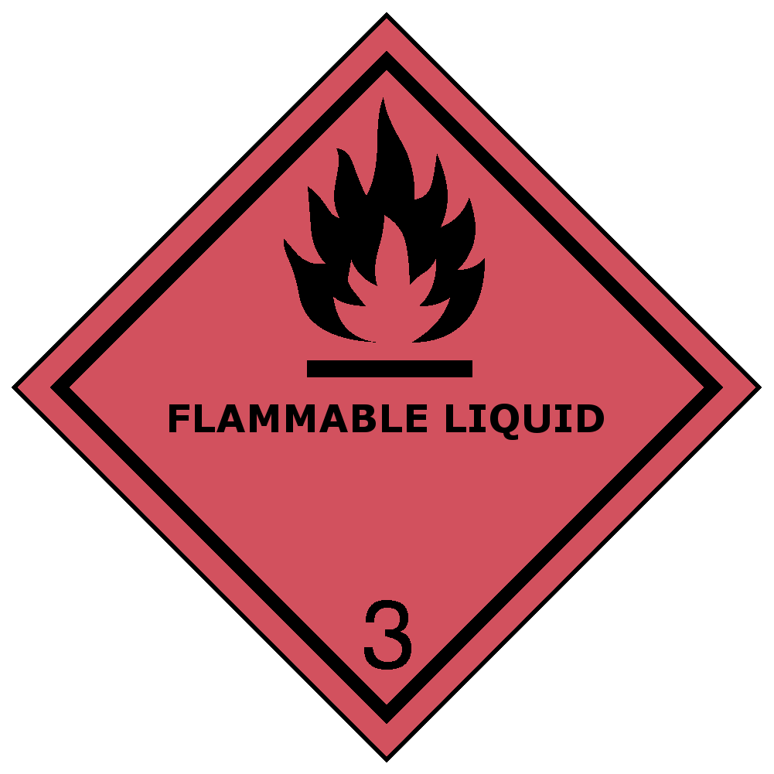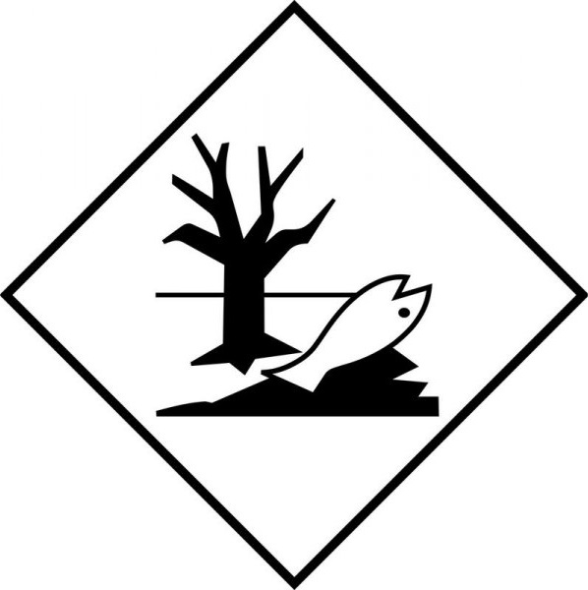 | 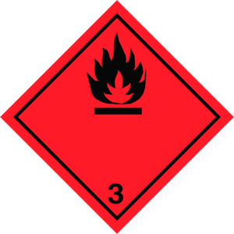
14.4. Packing group
III | III | III
14.5. Environmental hazards
Dangerous for the environment: Yes | Dangerous for the environment: Yes  Marine pollutant: Yes | Dangerous for the environment: Yes
No supplementary information available

14.6. Special precautions for user
DOT
UN-No.(DOT) | : | UN1263
DOT Packaging Exceptions (49 CFR 173.xxx) | : | 150
DOT Packaging Non Bulk (49 CFR 173.xxx) | : | 173
DOT Packaging Bulk (49 CFR 173.xxx) | : | 242
DOT Quantity Limitations Passenger aircraft/rail (49 CFR 173.27) | : | 60 L
DOT Quantity Limitations Cargo aircraft only (49 CFR 175.75) | : | 220 L
DOT Vessel Stowage Location | : | A - The material may be stowed ‘‘on deck’’ or ‘‘under deck’’ on a cargo vessel and on a passenger vessel.

IMDG
Special provision (IMDG) | : | 163, 223, 367, 955
Limited quantities (IMDG) | : | 5 L
Excepted quantities (IMDG) | : | E1
Packing instructions (IMDG) | : | P001, LP01
Packing provisions (IMDG) | : | PP1
IBC packing instructions (IMDG) | : | IBC03
Tank instructions (IMDG) | : | T2
Tank special provisions (IMDG) | : | TP1, TP29
EmS-No. (Fire) | : | F-E - FIRE SCHEDULE Echo - NON-WATER-REACTIVE FLAMMABLE LIQUIDS
EmS-No. (Spillage) | : | S-E - SPILLAGE SCHEDULE Echo - FLAMMABLE LIQUIDS, FLOATING ON WATER
Stowage category (IMDG) | : | A
Properties and observations (IMDG) | : | Miscibility with water depends upon the composition.

IATA
PCA Excepted quantities (IATA) | : | E1
PCA Limited quantities (IATA) | : | Y344
PCA limited quantity max net quantity (IATA) | : | 10L
PCA packing instructions (IATA) | : | 355
PCA max net quantity (IATA) | : | 60L
CAO packing instructions (IATA) | : | 366
CAO max net quantity (IATA) | : | 220L
ERG code (IATA) | : | 3L

14.7. Transport in bulk according to Annex II of MARPOL 73/78 and the IBC Code
Not applicable

SECTION 15: Regulatory information

15.1. US Federal regulations
All components of this product are present and listed as Active on the United States Environmental Protection Agency Toxic Substances Control Act (TSCA) inventory, except for:
Silicon dioxide, chemically prepared | CAS-No. No data | 3.2% max

This product or mixture is not known to contain a toxic chemical or chemicals in excess of the applicable de minimis concentration as specified in 40 CFR §372.38(a) subject to the reporting requirements of section 313 of Title III of the Superfund Amendments and Reauthorization Act of 1986 and 40 CFR Part 372.

Butanone (78-93-3)
Listed on EPA Hazardous Air Pollutant (HAPS)
CERCLA RQ | 5000 lb

Cyclohexanone (108-94-1)
CERCLA RQ | 5000 lb

15.2. International regulations

CANADA
Stoddard Solvent (8052-41-3)
Listed on the Canadian DSL (Domestic Substances List)

Naphtha, petroleum, light steam-cracked, debenzenized, polymers (68131-99-7)
Listed on the Canadian DSL (Domestic Substances List)

Paraffinic Napthenic Solvent
(64742-47-8)
Listed on the Canadian DSL (Domestic Substances List)

Octamethyl Cyclotetrasiloxane (556-67-2)
Listed on the Canadian DSL (Domestic Substances List)

Decamethylcyclopentasiloxane (541-02-6)
Listed on the Canadian DSL (Domestic Substances List)

2-Butoxyethanol (111-76-2)
Listed on the Canadian DSL (Domestic Substances List)

Cobalt 2-ethylhexanoate (136-52-7)
Listed on the Canadian DSL (Domestic Substances List)

Naphtha, petroleum, hydrodesulfurized heavy (64742-82-1)
Listed on the Canadian DSL (Domestic Substances List)

2-(2-butoxyethoxy)ethanol (112-34-5)
Listed on the Canadian DSL (Domestic Substances List)

Neodecanoic acid, manganese salt (27253-32-3)
Listed on the Canadian DSL (Domestic Substances List)

Manganese carboxylate (15956-58-8)
Listed on the Canadian DSL (Domestic Substances List)

Zirconium carboxylate (22464-99-9)
Listed on the Canadian DSL (Domestic Substances List)

Calcium Carboxylate (68551-41-7)
Listed on the Canadian NDSL (Non-Domestic Substances List)

Zinc bis(2-ethylhexanoate) (136-53-8)
Listed on the Canadian DSL (Domestic Substances List)

2-Butanone oxime (96-29-7)
Listed on the Canadian DSL (Domestic Substances List)

Butanone (78-93-3)
Listed on the Canadian DSL (Domestic Substances List)

Butan-2-ol (78-92-2)
Listed on the Canadian DSL (Domestic Substances List)

Cyclohexanone (108-94-1)
Listed on the Canadian DSL (Domestic Substances List)

Cyclopentanone (120-92-3)
Listed on the Canadian DSL (Domestic Substances List)

2,2'-Bipyridine (366-18-7)
Listed on the Canadian DSL (Domestic Substances List)

Dimethyl Carbonate (616-38-6)
Listed on the Canadian DSL (Domestic Substances List)

2,6-dimethylheptan-4-one (108-83-8)
Listed on the Canadian DSL (Domestic Substances List)

4,6-Dimethyl-2-heptanone (19549-80-5)
Listed on the Canadian DSL (Domestic Substances List)

2-methoxy-1-methylethyl acetate (108-65-6)
Listed on the Canadian DSL (Domestic Substances List)

Medium aliphatic naphtha (64742-88-7)
Listed on the Canadian DSL (Domestic Substances List)

Benzyl alcohol (100-51-6)
Listed on the Canadian DSL (Domestic Substances List)

Hydrocarbons, C9, aromatics (64742-95-6)
Listed on the Canadian DSL (Domestic Substances List)

Quartz (14808-60-7)
Listed on the Canadian DSL (Domestic Substances List)

EU-Regulations
No additional information available

National regulations
Stoddard Solvent (8052-41-3)
Listed on INSQ (Mexican National Inventory of Chemical Substances)

Paraffinic Napthenic Solvent
(64742-47-8)
Listed on INSQ (Mexican National Inventory of Chemical Substances)

Octamethyl Cyclotetrasiloxane (556-67-2)
Listed on INSQ (Mexican National Inventory of Chemical Substances)

Decamethylcyclopentasiloxane (541-02-6)
Listed on INSQ (Mexican National Inventory of Chemical Substances)

2-Butoxyethanol (111-76-2)
Listed on INSQ (Mexican National Inventory of Chemical Substances)

Cobalt 2-ethylhexanoate (136-52-7)
Listed on INSQ (Mexican National Inventory of Chemical Substances)

Naphtha, petroleum, hydrodesulfurized heavy (64742-82-1)
Listed on INSQ (Mexican National Inventory of Chemical Substances)

2-(2-butoxyethoxy)ethanol (112-34-5)
Listed on INSQ (Mexican National Inventory of Chemical Substances)

Zinc bis(2-ethylhexanoate) (136-53-8)
Listed on INSQ (Mexican National Inventory of Chemical Substances)

2-Butanone oxime (96-29-7)
Listed on INSQ (Mexican National Inventory of Chemical Substances)

Butanone (78-93-3)
Listed on INSQ (Mexican National Inventory of Chemical Substances)

Butan-2-ol (78-92-2)
Listed on INSQ (Mexican National Inventory of Chemical Substances)

Cyclohexanone (108-94-1)
Listed on INSQ (Mexican National Inventory of Chemical Substances)

Cyclopentanone (120-92-3)
Listed on INSQ (Mexican National Inventory of Chemical Substances)

2,2'-Bipyridine (366-18-7)
Listed on INSQ (Mexican National Inventory of Chemical Substances)

Dimethyl Carbonate (616-38-6)
Listed on INSQ (Mexican National Inventory of Chemical Substances)

2,6-dimethylheptan-4-one (108-83-8)
Listed on INSQ (Mexican National Inventory of Chemical Substances)

2-methoxy-1-methylethyl acetate (108-65-6)
Listed on INSQ (Mexican National Inventory of Chemical Substances)

Medium aliphatic naphtha (64742-88-7)
Listed on INSQ (Mexican National Inventory of Chemical Substances)

Benzyl alcohol (100-51-6)
Listed on INSQ (Mexican National Inventory of Chemical Substances)

Hydrocarbons, C9, aromatics (64742-95-6)
Listed on INSQ (Mexican National Inventory of Chemical Substances)

Quartz (14808-60-7)
Listed on IARC (International Agency for Research on Cancer)
Listed as carcinogen on NTP (National Toxicology Program)
Listed on INSQ (Mexican National Inventory of Chemical Substances)

15.3. US State regulations
WARNING: | This product can expose you to Quartz , which is known to the State of California to cause cancer. For more information go to www.P65Warnings.ca.gov.

SECTION 16: Other information
according to Federal Register / Vol. 77, No. 58 / Monday, March 26, 2012 / Rules and Regulations
Full text of H-phrases
H225 | Highly flammable liquid and vapor
H226 | Flammable liquid and vapor
H227 | Combustible liquid
H301 | Toxic if swallowed
H304 | May be fatal if swallowed and enters airways
H312 | Harmful in contact with skin
H315 | Causes skin irritation
H317 | May cause an allergic skin reaction
H318 | Causes serious eye damage
H319 | Causes serious eye irritation
H336 | May cause drowsiness or dizziness
H340 | May cause genetic defects
H350 | May cause cancer
H361 | Suspected of damaging fertility or the unborn child
H370 | Causes damage to organs
H373 | May cause damage to organs through prolonged or repeated exposure
H410 | Very toxic to aquatic life with long lasting effects
H411 | Toxic to aquatic life with long lasting effects
This information is based on our current knowledge and is intended to describe the product for the purposes of health, safety and environmental requirements only. It should not therefore be construed as guaranteeing any specific property of the product.

